**Reviewers:**

|  |  |  |
| --- | --- | --- |
| Prof. John H. McDonald | Biology Department, Western Washington University, Bellingham, Washington 98225 | mcdona44@wwu.edu |
| Dr. Kati Michalek | SAMS, Scottish Marine Institute, Oban, Argyll, PA37 1QA | [Kati.Michalek@sams.ac.uk](mailto:Kati.Michalek@sams.ac.uk) |
| Dr. María Angélica Larraín Barth | Departamento de Ciencia de los Alimentos y Tecnología Química, Facultad de Ciencias Químicas y Farmacéuticas, Universidad de Chile, Santos Dumont Nº 964 , Independencia | [mlarrain@uchile.cl](mailto:mlarrain@uchile.cl) |
| Dr. F.P. (Frank) Wesselingh | Naturalis Biodiversity Center, Darwinweg 2, 2333 CR Leiden, Netherlands | frank.wesselingh@naturalis.nl |

**Abstract**.

Cryptic species as well as hybridizing species could lack diagnostic taxonomic characters leaving researchers with semi-diagnostic markers. Taxa identification by such markers is probabilistic and the probability of correct identification is dependent on the taxonomic structure of populations. Cryptic blue mussel species *Mytilus edulis* and *M. trossulus* co-occur and hybridize in multiple areas of North Atlantic and neighboring Arctic. Blue mussels are ecologically, stratigraphically and economically important molluscs. Their studies will benefit from any cues to distinguish species in sympatry without genotyping. Recently it was shown that in the White Sea species statistically differs by a simple conchological trait (morphotype). In the paper we analyzed the associations between morphotypes and species-specific genotypes in an abundant material from the waters of Kola Peninsula (White Sea, Barents Sea) and in more limited material from Norway, the Baltic Sea, Scotland and the Gulf of Maine. The performance of the “morphotype test” for species identification was formally evaluated using approaches from evidence-based medicine. Interspecific differences in the morphotype frequencies were ubiquitous and unidirectional, but their scale varied geographically (from 65% in the White Sea to 6% in the Baltic Sea). In addition, salinity-related variation within *M. edulis* was revealed in the Barents Sea. For every studied region we established empirical relationships between the proportions of the morphotypes in the populations and their taxonomic structure as well as between the proportions of the morphotypes in samples and the probabilities of mussels of different morphotypes being *M. trossulus* and *M. edulis*. Recommendations for application of a test for mussels from the unstudied contact zones were provided. These recommendations are applicable with the same success to any other taxa, which lack fixed diagnostic morphological characters and are identified by semi-diagnostic traits.

**Introduction**

Blue mussels *Mytilus edulis* and *M. trossulus* are old evolutionary lineages of Pliocene origin (Riginos, Cunningham 2005). A more common *M. edulis* is thought to be native in the Atlantic, while the basically Pacific *M. trossulus* has colonized the northwest Atlantic in a series of multiple natural and anthropogenic invasions (Rawson, Harper 2009; Vainola, Strelkov 2011; Wenne et al. 2016). Now these two species co-occur and hybridize in at least six geographical areas of the North Atlantic and the adjacent Arctic: Western Greenland, American coast from the Gulf of Maine to Hudson Bay, Northeastern Scotland, Western Baltic Sea, Western Norway and the coasts of the Kola Peninsula in Russia (White Sea, Barents Sea) (Wenne et al. 2020 and references therein).

Ever since the existence of *M. trossulus* was recognized by molecular genetic markers (Varvio et al. 1988), the search has been on for reliable morphometric characters allowing one to distinguish it from *M. edulis*. The discreteness of these two species was confirmed in studies employing numerous metric shell traits and a multidimensional approach, but no individually informative characters have been found (McDonald et al. 1991; Mallet, Carver 1995; Innes, Bates 1999; Telesca et al. 2018). Therefore *M. edulis* and *M. trossulus* are generally treated as cryptic species and are routinely identified genetically. While multilocus analysis is desirable for an unambitious identification of species and their hybrids, in practice singular presumably diagnostic markers are usually employed, most often the protein coding region for the polyphenolic adhesive protein (ME 15/16 or Glu-5’) (Larrian et al. 2019).

*Mytilus edulis* and *M. trossulus* are ecologically, economically and stratigraphically important molluscs (Seed, Suchanek 1992; FAO 2020; Mangerud, Svendsen 2018). Apart from their biogeographic histories, these two species are known or suspected to differ in life traits, ecological requirements and properties as biomonitoring and aquaculture objects (Lobel et al. 1990; Katolikova et al. 2016; Michalek et al. 2016; Beyer et al. 2017 and references therein). The most illustrative example is the harm associated with *M. trossulus* invasion on longline aquaculture designed for *M. edulis*. A cryptic presence of *M. trossulus* in *M. edulis* plantations in Loch Etive (Scotland) in the 2000s resulted in significant production losses because *M. trossulus* had lower consumer properties and shells too fragile for harvesting and grading (Beaumont et al. 2008; Dias et al. 2011). Considerable differences between species were also found in Canadian aquaculture (Mallet & Carver, 1995; Penny et al. 2002), where the commercial value of *M. trossulus* was estimated to be 1.7 times lesser than that of *M. edulis* (Mallet & Carver 1995). The impossibility of identifying *M. edulis* and *M. trossulus* by the shells is frustrating, and any cue for distinguishing these species in sympatry without genotyping would be a welcome addition to the toolkit of mussel studies.

We have recently discovered that *M. edulis* and *M. trossulus* in the White Sea differ by a simple conchological trait: the presence or absence of an uninterrupted prismatic strip under the ligament on the inner side of the shell. This strip is found in 74% of *M. trossulus*-like mussels (i.e. mussels with multilocus genotypes dominated by *M. trossulus* genes; this group mostly consists of purebreds but also includes some hybrids), while 96% of *M. edulis*-like mussels lack this character (Katolikova et al. 2016; Khaitov et al. 2018). Hence we denote the mussels that bear the strip as the T-morphotype and those that lack this strip, as the E-morphotype.

This finding raises two questions. The first is how to apply this marker for individual and population assignment correctly and efficiently. Species identification is usually based on fixed diagnostic traits, which have a unique state for all individuals of a species. The conchological trait under consideration is not diagnostic but semi-diagnostic, i.e. polymorphic within species but with states distributed in different frequencies across species (see Padial et al. 2010). Since there are strong (70%) differences in the morphotype frequencies between the mussel species in the White Sea, one can fall into a trap of deciding that any T-morphotype mussel from the White Sea can be assigned with a high probability to *M. trossulus* while any E-morphotype mussel can be assigned to *M. edulis*. In fact, however, the probabilities of correct identification depend on the proportion of *M. trossulus* and *M. edulis* in the population under study. Any mussel sampled from a “pure” *M. trossulus* population (an expected T-morphotype frequency *PT* = 74%) would be *M. trossulus* regardless of the morphotype. By the same token, any mussel sampled from a “pure” *M. edulis* population (*PT* =4%) would be *M. edulis*. At the same time, in a 1:1 mixture of species (expected *PT* = (74+4)/2 = 39%), 95% of the T-morphotypes would be *M. trossulus* (*P(tros|T)* = 0.74*0.5/(0.39) = 0.949), while 79% of the E-morphotypes would be *M. edulis* (*P(edu|E)* = 0.96*0.5/(1-0.39) = 0.787). However, these calculations can be considered as accurate only if the frequencies of the morphotypes within species-specific genotypes do not vary with the taxonomic structure of populations.

In such a situation, taxonomists may profit from the experience of clinicians. They often have to deal with semi-diagnostic characters since many clinical diagnostic tests employ semi-diagnostic markers. A formal procedure has been developed in evidence-based medicine to evaluate the ability of clinical tests to classify patients as having or not having the target condition relative to the reference standard (e.g. Banoo et al. 2007). We suggest that this methodology might be useful for the evaluation of taxonomic tests for cryptic species relative to the species-specific genotype. To emphasize the analogy with the clinical approach, we refer to the procedure of mussel species identification based on the morphotype as the “morphotype test”.

The second question is whether the basic morphological differences between *M. trossulus* and *M. edulis* revealed in the White Sea are a local phenomenon or whether these two species can be distinguished by the morphotype in other populations and contact zones as well. Should the latter prove true, the morphotype test would considerably facilitate local mussel studies in the Atlantic. Since difference between species in the trait under consideration were overlooked in previous morphometric studies that were all based on references from other populations (McDonald et al. 1991; Mallet, Carver 1995; Innes, Bates 1999; Telesca et al. 2018) it is not improbable that this difference is valid only at the White Sea. The reasons may be associated with its unusual environmental features such as a combination of the subarctic climate and a relatively low salinity (below 25 ppt — Derjugin 1928) and/or the history of the local *M. trossulus*. This species is thought to have invaded the Kola Peninsula through marine traffic very recently, in the middle of the 20th century, while most of its other Atlantic populations are probably much older (Vainola, Strelkov 2011).

In this paper we address the above two questions. Firstly we analyze the associations between morphotypes and species-specific genotypes in an abundant material from the waters of the Kola Peninsula and in limited material from Norway, the Baltic Sea, Scotland and the Gulf of Maine. For the Kola material, we compare populations from the marginal White Sea and from the oceanic Barents Sea coasts on the one hand and populations from the brackish and the saline localities in the Barents Sea on the other hand. The purpose is to see how local geography and salinity (or associated factors) affect morphotype frequencies in populations with a similar biogeographic history existing under similar climatic conditions. Secondly, we formally evaluate the performance of the “morphotype test” for species identification using approaches from evidence-based medicine and provide practical recommendations for its use for population and individual assessment.

**Materials and Methods**

**Samples.** Altogether, we considered 77 mussel samples (total sample size N = 4325, individual sample size N=18-173) representing five geographical contact zones between *M. edulis* and *M. trossulus*: the Gulf of Maine in the NW Atlantic (12 samples, N = 428), Loch Etive in Northern Scotland (2 populations, N = 160), Western Baltic Sea (8 samples, N = 638), Bergen city area in Western Norway (5 samples, N = 365) and the coasts of the Kola Peninsula in Northern Russia: 24 samples from the White Sea (N =1089) and 26 samples from the Barents Sea (N = 1645). Detailed information about samples and sampling localities is provided in the **S1 Table**.

The Barents Sea samples were taken in the Kola Bay and at the open oceanic coast of Eastern Murman. Based on the salinity in the sampling localities, they were classified into brackish (salinity 5-30 ppt) and saline (>30 ppt). The first group consisted of nine samples from the freshened top of the Kola Bay and three samples from the open coast. The second group consisted of eight samples from the mouth of the Kola Bay and six samples from the open coast (**Fig. 1**).

As for the samples from other contact zones, all American samples and two out of five Norwegian samples were from saline habitats, while all the others were from brackish habitats. Salinity conditions in the sampling localities were either taken from the literature (Derjugin 1915; Ridgway, Nævdal, 2004; Bobkov et al. 2010; Dias et al. 2009; Kingston et al. 2017; Shavykin 2018) or, in case of the few American and the Barents Sea open coast localities, predicted based on the presence or absence of large rivers nearby.

In addition to the samples taken in the five contact zones, we identified the morphotypes in 27 samples (total sample size N=912, individual sample size N=12-76) of supposedly pure blue mussel species from distant localities: *M. trossulus* from Passamaquoddy Bay and *M. edulis* from the Gulf of Saint Lawrence in Eastern Canada, *M. trossulus* from the Northern Baltic Sea, from Puget Sound in Eastern Pacific and from multiple areas of Western Pacific, *M. edulis* from SW Greenland, from the Long Island Sound and Cape Cod in the Eastern USA, and from saline and brackish localities in Europe and in the SW Barents Sea (**Fig.1**, **S2 Table**). Information about the species identity of regional populations and salinity conditions in sampling localities was taken from the literature. Taxonomic affinities of mussels from Canada and from Western Norway, where both species could be expected, were confirmed genetically (see **S2 Table** for details).

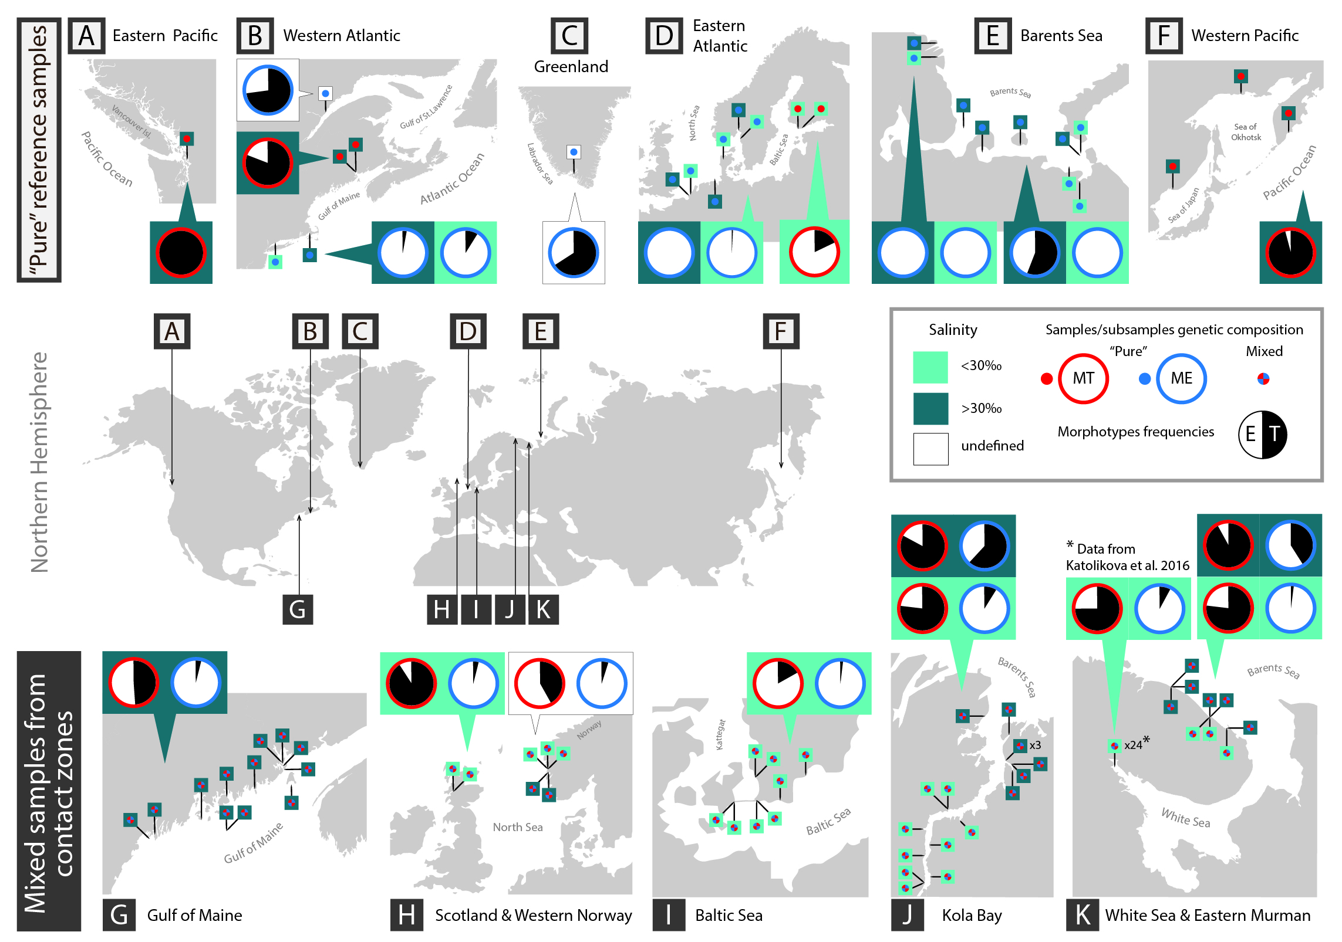

**Fig 1.** Map of the study area. Bottom maps (G-K) show five geographical contact zones between *M. edulis* and *M. trossulus*, upper maps (A - F), other studied areas. Pins depict sampling sites. Pie diagrams depict proportions of T-morphotypes (black sector) and E-morphotypes (white sector) in *M. trossulus* (diagrams with a red border) and *M. edulis* (those with a blue border) in combined samples from particular regions. If the data on salinity in sampling localities are available and considered in the analyses, it is indicated by the color of pins (light green – brackish, dark green - saline) and the proportions of the T-morphotypes in combined samples from brackish and saline localities are presented separately in diagrams placed on light and dark green background, respectively. Source data are given in **S1 Table** and **S2 Table**.

**Genetic characters.** Some samples from the contact zones were genotyped in previous studies (8 of 12 American samples: Kingston et al. 2017, Martino et al. 2019; 6 of 8 Baltic samples: Vainola, Strelkov 2011, Strelkov et al. 2017; 2 of 5 Norwegian samples: Vainola, Strelkov 2011; 1 of 26 the Barents Sea samples: Vainola, Strelkov 2011; all the White Sea samples: Katolikova et al. 2016). The other samples were taken specially for the purpose of this study (see **S1 Table**). For mussels from the published studies multilocus nuclear genotypes were available. The Gulf of Maine mussels were genotyped using 171 645 random SNPs (single nucleotide loci) (Kingston et al. 2017), while the mussels from the other areas were genotyped using sets of allozyme loci each time including four “nearly diagnostic” (70–95% allele frequency differences between *M. edulis* and *M. trossulus*) Est-D, Gpi, Pgm and Odh loci. New samples from the Gulf of Maine were genotyped as in Kingston et al. 2017, while other samples were genotyped by Est-D, Gpi, Pgm and Odh as in Katolikova et al. 2016. For seven samples from the Barents Sea the data on only three loci—Est-D, Gpi and Pgm—were available (see **S1 Table**). SNP set and each of the four regional 4-locus allozyme sets (from the Baltic, Norway, Scotland and Russia) were analyzed separately using STRUCTURE or fastSTRUCTURE software (Pritchard et al. 2000, Raj et al. 2014, settings as in Katolikova et al. 2016 and Kingston et al. 2017). Structure q-values defined as proportion of *M. trossulus* genes in individual genotypes were estimated (proportion of *M. edulis* genes is therefore 1-q). The material from Russia was also analyzed by three loci (Odh not considered) to show that the exclusion of Odh did not affect the inference (data not shown). Mussels were classified into two categories by their q-values: genotypes dominated by *M. trossulus* genes (q-value > 0.5) and genotypes dominated by *M. edulis* genes (q-value ≤ 0.5). For ease of presentation, these categories will be referred to as “*M. trossulus*” and “*M. edulis*” genotypes though each includes both purebreds and hybrids. Other genetic information but results of classification into *M. trossulus* and *M. edulis* will not be considered here. A detailed analysis of the hybrid zones under consideration, in particular, the proportions of purebreds and hybrids in mixed samples, are available in the literature (Vainola, Strelkov 2011; Katolikova et al. 2016; Kingston et al 2017; Strelkov et al. 2017; Wenne et al. 2020 and references therein).

**Morphological characters.** Data on the White Sea samples were taken from Katolikova et al. 2016 and the other samples were processed accordingly. We measured the maximum length of each shell to the nearest 0.1 mm with electronic calipers and investigated the inner surface of the valves under a dissecting stereo-microscope. A mussel was classified as a T- or an E-morphotype based on, respectively, presence or absence of an uninterrupted strip of the prismatic layer under the ligament on the inner side of the shell. To note, this strip was additionally defined as “dark” in our previous papers (Katolikova et al 2016; Khaitov et al 2018) since mussels from the White Sea usually possess a dark prismatic layer, and T-morphotypes were illustrated with photos where the strip was both dark and quite wide. The analysis of the new material revealed some geographical variation in the coloration and width of the “strip”. We specify the definitions of the two morphotypes in the Results and provide more illustrations in the ESM.

**Predictive values.** For each sample we calculated the frequencies of *M. trossulus* (*Ptros*) and T-morphotypes (*PT*) and four indices reflecting the strength of association between genotypes and morphotypes: *P(T|tros)* - the proportion of T-morphotypes among *M. trossulus*, *P(E|edu)* - the proportion of Е-morphotypes among *M. edulis* (for practical reasons we used *P(T|edu)*=*1- P(E|edu)*, the proportion of T-morphotypes among *M. edulis*), *P(tros|T)* - the proportion of *M. trossulus* among T-morphotypes, *P(edu|E)* - the proportion of *M. edulis* among E-morphotypes. *P(tros|T)* and *P(edu|E)* are the key indices because they show, respectively, how likely it is that a randomly taken T-morphotype mussel is *M. trossulus* and a randomly taken E-morphotype mussel, *M. edulis*.

Here we would like to offer an analogy between the indices used in our study and those used in clinical medicine for evaluating the performance of diagnostic tests. If we consider *M. edulis* as a “healthy” mussel and *M. trossulus* as a “sick” mussel (which is not so far-fetching considering the threat presented by *M. trossulus* to the Scottish aquaculture, Beaumont et. al. 2008), then our terms have the following medical equivalents (Banoo et al. 2007): *Ptros* is *prevalence*, *P(T|tros)* is *sensitivity*, *P(E|edu)* is *specificity*, *P(tros|T)* is *positive predictive value* and *P(edu|E)* is *negative predictive value* of the morphotype test.

It is axiomatic that for clinical tests (and when sensitivity and specificity<1) positive and negative predictive values vary with prevalence (Banoo et al. 2007). With the increasing *Ptros*, *P(tros|T)* will gradually increase from 0 in pure populations of *M. edulis* to 1 in pure populations of *M. trossulus*, while *P(edu|E)* will demonstrate an opposite relationship. For the test to be meaningful, predictive values should be >0.5 since a predictive value of 0.5 indicates a random association between the genotype and the morphotype. Assuming that sensitivity and specificity do not depend on the prevalence (though this assumption may be violated, see below), predictive values could be directly predicted basing on the *Ptros* in a sample and the known sensitivity and specificity using the formulas:

*P(tros|T) = Ptros*\**P(T|tros)/(*1 - *Ptros)*\**(P(T|edu))* + *Ptros*\**P(Т|tros)* [Eq 1]

*P(edu|E) = ((1 - Ptros)*(1-P(T|edu))/((1- Ptros)*(1-P(T|edu)) + Ptros*(1 - P(Т|tros))* [Eq 2]

In its turn, the prevalence (*Ptros*) could be predicted based on *P(T|edu)*, *P(T|tros)* and *PT* in a sample:

*Ptros* = *(PT – P(T|edu)))/ (P(T|tros) - P(T|edu))* [Eq 3]

**Statistical analyses.** The following analyses were made using the data from the contact zones. Firstly, we studied variation of *PT*, *P(T|tros)*, *P(T|edu)*, *P(tros|T*), *P(edu|E)* as functions of *Ptros* within and between sample sets representing A) the White Sea (sample set WS) and the Barents sea coasts of the Kola Peninsula and saline (set BH) and brackish (set BL) water localities in the Barents Sea (Section “Associations between morphotypes and species-specific genotypes around the Kola Peninsula”), B) different geographical contact zones between species. Whenever possible, formulas describing empirical relationships between *Ptros* and *PT* and between positive (*P(tros|T)*)and negative (*P(edu|E)*) predictive values and *Ptros* were derived on the basis of regression analysis (Section “Associations between morphotypes and species-specific genotypes around the Atlantic”). Secondly, we analyzed genotype-specific associations between morphotypes and the shell size in order to verify the hypothesis that morphological variation under consideration is not related to mussel size (Section “Associations between morphotypes and shell size”). Finally, we tested how well *Ptros,* *P(edu|E)* and *P(tros|T)* could be predicted using formulas Eq 1-3 and the data on the morphotype proportions among species (*P(T|tros)*, *P(T|edu)*) in a few genotyped samples. We concede that the assumption that sensitivity and specificity do not depend on the prevalence can be violated in the morphotype test, as it often is in clinical tests (Leeflang et al. 2009, 2013). Therefore we focused on finding out which samples were better suited for prediction on the basis of Eq. 1-3: the most mixed samples (*Ptros*~0.5) or the combination of the two most pure samples of each species. The samples identified in this way as best suited for prediction can be used as “calibrating” ones. (Section “Prediction of taxonomic structure of populations and predictive values of the morphotype test based on probability calculators”).

All statistical analyses were performed with functions of R3.6.1 statistical programming language (R Core Team, 2019). We used generalized linear (mixed) models, GL(M)Ms, with binomial distribution and a logit link-function. All GLM models were constructed with glm() function from the package “stats” (R Core Team, 2019) whereas GLMM were fitted with glmer() function from the package “lme4” (Bates et al 2015). The validity of each model was checked by visual analysis of residual plots and the assessment of the overdispersion presence.

The goodness of fit for the models was assessed by means of pseudo-R2 (Nakagawa and Schielzeth 2013) using the function r.squaredGLMM() from the package “MuMIn” (Barton 2018). To assess the role of random factors in GLMM, we compared marginal and conditional pseudo R2 (Nakagawa and Schielzeth 2013). After the model parameters were estimated, we visualized them by means of regression lines with corresponding 95% confidence intervals.

**Associations between morphotypes and species-specific genotypes around the Kola Peninsula***.* The following three regression models were fitted for the data.

**Model 1**: Morphotype proportions (*PT*) as a function of taxonomic structure of mussel populations (*Ptros*). All mussels with a T-morphotype were coded as 1 and all mussels with an E-morphotype were coded as 0. These data were used as a dependent variable, which was regressed against *Ptros* (continuous predictor) and *Set* (discrete predictor with three levels) and interaction between them.

**Model 2**: Morphotype proportions among species (*P(T|tros)*, *P(T|edu)*) as a function of taxonomic structure of populations (*Ptros*). The dependent variable was coded as in Model 1 and modelled as a function of *Ptros*, *Set*, *Species* (a discrete predictor with two levels) and interaction between terms. The sample was included into the model as a random factor influencing the model intercept.

**Model 3**: Correctness of species identification (*P(tros|T)* and *P(edu|E)*) as a function of taxonomic structure of populations. The dependent variable was coded as 1 if *M. trossulus* was represented by the T-morphotype or *M. edulis* was represented by the E-morphotype and as 0 in the other cases. The set of predictors for the model was as follows: *Ptros*, *Morphotype* (discrete predictor with two levels), *Set* and interaction between terms. The sample was included into the model as a random factor influencing the model intercept.

To check whether it is possible to pool some of the geographical sets to construct a more general model without losing information, we constructed three complex data sets with different pairing combinations of WS, BL and BH: (WSBL) and BH; (WSBH) and BL; (BLBH) and WS. We did not consider a full combination of sets since in such a case the factor “Set” would be discarded from the model. We applied the structure of Model 3to these new recombined datasets. Then we compared AICs of these new models with AIC of Model 3 based on non-pooled data. If AIC of a new model was less than the AIC of the initial one, we considered this as a basis for pooling of the corresponding sample sets.

**Associations between morphotypes and species-specific genotypes around the Atlantic**. Five sample sets were considered, representing the Gulf of Maine (GOM), the Baltic Sea (BALT), Western Norway (NORW), saline Barents Sea (BH) and the White Sea combined with the brackish Barents Sea (WSBL, sets WS and BL were pooled since they did not differ statistically, see Results). Scotland (SCOT) was not included in regression analyses because it was represented by only two samples. Three models were constructed:

**Model 4.**  Taxonomic structure (*Ptros*) as a function of morphotype frequencies in populations (*PT*). The dependent variable was coded as in Model 1 and modelled as a function of PT (continuous predictor), *Set* and interaction between them. We modeled *Ptros* vs. *PT* but not vice versa, as in the previous analysis, in order to use this model as a reference for the “*Ptros* by *PT* calculator” (see below).

**Model 5.**  Morphotype proportions among species (*P(T|tros)*, *P(T|edu)*) as a function of taxonomic structure of populations (*Ptros*). The model was constructed analogously to Model 2.

**Model 6.** Correctness of species identification (*P(tros|T*) and *P(edu|E)*) as a function of taxonomic structure of populations (*Ptros*). The model was constructed analogously to Model 3.

**Associations between morphotypes and shell size.** To check the possible association of morphotypes with size we undertook the following two analyses. Firstly, we constructed a set logistic regression models for each available species-specific genotype (i.e. *M. edulis* or *M. trossulus*) from each sample. The probability of the presence of the T-morphotype was a dependent variable and mussel size was a predictor in these models. Only cases where slope-terms of the models were statistically significant (p < 0.05) after Hochberg’s correction for multiple testing (REF- Quinn and ...) were considered. Secondly, we checked the presence of any patterns in residuals from Model 6 (i.e. the main model designed to predict the probability of correct identification of an individual mussel by its morphotype) as a function of mussel size.

**Prediction of taxonomic structure of populations and predictive values of the morphotype test based on probability calculators.**

We applied Eq. 1-3 to predict *Ptros*, *P(edu|E)* and *P(tros|T)* for samples from each data set (*GOM*, *BALT*, *NORW*, *BH*, *WSBL*, *SCOT*) using estimates of morphotype proportions among species (*P(T|tros*), *P(T|edu)*) obtained from combinations of “calibrating” samples selected based on the results of the following analysis.

We considered all 630 possible pair combinations of samples from the *WSBL* dataset. Each pair was characterized by an index of taxonomic similarity between the samples:

Delta = (*Ptros1)* * (1 - *Ptros2*) + (*Ptros2*) * (1 - *Ptros1*) [Eq. 4],

where *Ptros1* and *Ptros2* – higher and lower estimates of prevalence in samples. The index varies in a range [0; 1] and takes the value Delta=0 when both samples are pure *M. edulis* (*Ptros1* = *Ptros2* = 0) or pure *M. trossulus* (*Ptros1* = *Ptros2* = 1), Delta=0.5 when both samples are equivalent mixtures of two species (*Ptros1* = *Ptros2* = 0.5) and Delta=1 when one sample represent pure *M. trossulus* (*Ptros1* = 1) and another pure *M. edulis* (*Ptros2* = 0).

Estimates of *P(T|tros)*, *P(T|edu)* and *PT* were obtained from pooled data on each pair of samples and used for calculation of predicted values of *P(edu|E)* and *P(tros|T)* basing on Eq.1,2 for the range of *Ptros* [0;1] with the step 0.01 (“genotype by morphotype calculator”) and predicted values of *Ptros* basing on Eq.3 for the range of *PT* [0;1] with the step 0.01 (“*Ptros* by *PT* calculator”). (Note that dealing with Eq. 1, 2 we assume here that *Ptros* is known while in reality it should be assessed using Eq. 3). Values of *P(edu|E)* and *P(tros|T)* obtained by Eq. 1, 2 were contrasted the ones predicted by the Model 6, and values of *Ptros* obtained by Eq. 3 were compared with predictions of Model 4 using correspondence statistics:

Goodness = 1 / mean((Regression prediction - Equation prediction) 2 ) [Eq.5]

Goodness varies (0; infinity) and approach to zero when predictions of models agrees poorly.

Goodness indices for each pair were plotted against the corresponding Delta values and the LOESS regression curve was fitted to find associations between them. Depending on the results of the analyses, we determined which combinations of samples could be used for predictions with best results. Best combinations of samples from each set were used to assess *P(T|edu)* and *P(T|tros)* as parameters of Eq. 1-3. Then we calculated predictions from Eq. 3 for the range of *PT* and predictions from Eq. 1-2 for the range of *Ptros*. These predictions were visually compared with that from regression Model 4 and Model 6, respectively.

Additionally, we tested the “lazy *Ptros* by *PT* calculator” which implies that samples with highest and lowest *PT* in regional sample sets do represent pure *M. trossulus* and *M. edulis* respectively and morphotype frequencies in these samples could be directly used as parameters *P(T|tros)* and *P(T|edu)* of Eq. 3. *Ptros* values predicted by the calculator for samples from different sets were visually compared with empirical ones.

For illustrative purposes and for the convenience of potential users of the “morphotype test” or any similar semi-diagnostic tests we provide the online “Ptros by PT” and “genotype by morphotype” probability calculators implementing Eq. 1-3 at +++++.

**Results**

**Geographical variation in the manifestation of mussel morphotypes.** The binary morphological character under consideration was previously defined, based on the material from the White Sea, as the “presence/absence of a distinct uninterrupted dark prismatic strip under the ligament” (Katolikova et al. 2016; Khaitov et al., 2018). In this study, which was based on the material from different geographical zones, E-morphotypes in all the populations looked the same and conformed to our previous description: the strip was absent, and the nacreous layer totally or partially covered the space under the ligament nympha (**S1 Fig A, C**). However, T-morphotypes showed some variation previously unrecorded in the White Sea. Firstly, most populations examined in this study contained, though rarely, shells in which the nacreous-free strip of the prismatic layer was quite narrow and looked like a stria rather than a strip. Secondly, in all T-morphotypes from the Gulf of Maine populations and in rare T-morphotypes from the other populations the strip was not dark but pale, as the prismatic layer itself. In such cases, T-morphotypes were difficult to notice by an unaided eye. They could be unambiguously identified only with the help of a dissecting microscope by the presence of a pronounced scar defining the boundary of the nacreous layer under the ligament nympha (**S1 Fig**).

Therefore, we propose an amended description of the character used to distinguish the E-morphotype and the T-morphotype: the presence/absence of an uninterrupted strip of the prismatic layer under the ligament nympha clearly recognizable by a scar separating the strip from the nacreous layer of the rest of the shell. This description was applicable to all the mussel populations examined in this study.

**S1 Fig.** Variation in the manifestation of mussel morphotypes. A-D. Stereoscopic micrographs of the ligament area of mussel valves. Note that scale bars differ between A-C and D. Strip of the prismatic layer under the ligament nympha is indicated by the arrows. A, B. E-morphotypes: the space under the ligament nympha is totally (A) or partially (B) covered by the nacre. C, D. T-morphotypes: a strip of uncovered prismatic layer under the ligament nympha is dark and wide (C; typical of most examined populations) or pale and narrow, recognizable by a scar separating it from the nacreous layer (D; typical of the Gulf of Maine populations). E. External and internal features of the shell valves of *M. trossulus* (left) and *M. edulis* (right) genotypes from Kola Bay (the largest mussels from sample Sev.17 in S1 table). In most cases T- morphotypes (marked by *) and E-morphotypes could be distinguished by an unaided eye. (будет переделано)

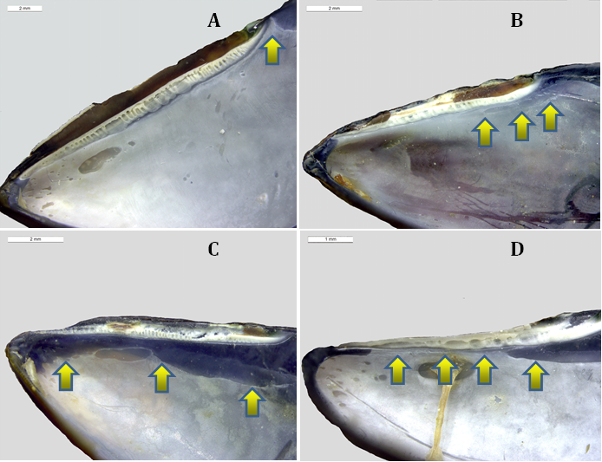



**Associations between morphotypes and species-specific genotypes around the Kola Peninsula**

Variation patterns of *PT*, *P(T|tros)*, *P(T|edu)*, *P(tros|T)*, *P(edu|E)* as functions of *Ptros* in samples from the White Sea (*WS*), the brackish Barents Sea (*BL*) and the saline Barents Sea (*BH*) are visualized in **Fig. 2.** The results of the regression analysis are summarized in **Table 1**.

A significant positive association between the proportions of *M. trossulus* (*Ptros*) and the proportions of T-morphotypes (*PT*) in samples was revealed for all the three sample sets (Model 1, **Table 1**, **Fig. 2**). For *WS* and *BL*, the data points were generally scattered around the Y=X line, while the regression lines approached it closely, indicating a high proportionality between *Ptros* and *PT*. For BH, the data points were scattered above the Y=X line and the regression line lay higher that the regression lines constructed for *WS* and *BL*. This means that in samples with a similar taxonomic structure, the frequencies of T-morphotypes were always higher in the saline localities in the Barents Sea than in the White Sea and the brackish localities in the Barents Sea.

The analysis of the frequencies of T-morphotypes in subsamples of *M.edulis*, *P(T|tros)* and *M.trossulus*, *P(T|edu)* against proportions of *M. trossulus* in samples (*Ptros*) revealed the following patterns (Model 2, Table 1, Fig. 2). There was a universal tendency towards a higher frequency of T-morphotypes among *M. trossulus* than among *M. edulis*. This tendency was quite strong in *WS* and *BL* (expected differences in morphotype frequencies between species about 0.65 for *Ptros*=0.5). In *BH* it was rather weak (expected differences 0.18 for *Ptros*=0.5) due to an increased *P(T|edu)* but significant (confidential intervals for *Ptros*=0.5 did not overlap, Fig. 2). A positive correlation of *P(T|tros)* and *P(T|edu)* with *Ptros* was found in all the three subsets. This means that with the increasing contribution of *M. trossulus* to the samples the frequencies of T-morphotypes increased considerably both among *M. edulis* and among *M. trossulus*.

The probability of correct identification of *M. trossulus* by the T-morphotype (the frequency of *M. trossulus* among T-morphotypes (*P(tros|T)*) expectedly increased with the increasing *Ptros*, while the probability of correct identification of *M. edulis* by the E-morphotype (*P(edu|E)*) demonstrated an opposite pattern (Model 3, Table 1, Fig. 2). In the *M. trossulus* - dominated populations, *P(tros|T)* tended to one (any mussel with a T-morphotype is 100% *M. trossulus*), while *P(edu|E)* tended to zero (any mussel with an E-morphotype is 100% *M. trossulus*), and vice versa. In the well-mixed samples (*Ptros* = 0.5) the predictive values for both species were about 0.75-0.85 in WS and BL but only 0.60 - 0.70 in BH (Fig. 2). It means that the morphotype test has a much lower predictive value in the saline Barents Sea than in the brackish Barents Sea and in the White Sea (the predictive value of 0.5 means a random association between the genotype and the morphotype). It is evident from **Fig. 2** that a low predictive value of the test in *BH* is mainly due to a generally low *P(T|tros)*.Nevertheless, the statistical analysis indicates that both *P(tros|T)* and *P(edu|E)* predicted by the model were smaller in BH than in WS and BL.

For each of the GLMM models considered (Model 2 and 3), marginal and conditional pseudoR2 were close to each other (**Table 1**). This indicates that the role of the random factor (*Sample*) as regulator of models was weak, i.e. the reproducibility of the results in different populations was satisfactory.

In inter-setcomparisons, the regression coefficients did not differ statistically for *WS* and *BL* sets, while *BH* was always different from *WS* (Table 1). To assess the possibility of pooling the data sets, we compared the AIC of Model 3 (AIC=2175.1) with AICs of three other models based on differently pooled WS, *BL* and *BH* sets. The model based on pooled *WS* and *BL* (*WSBL*) and *BH* showed the lowest AIC (AIC=2172.7). Therefore, in the following analyses we will consider two sets, *WSBL* and *BH*.

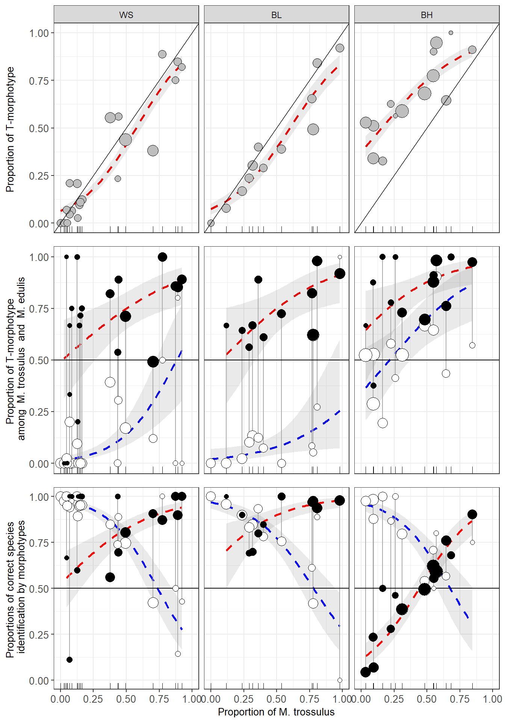

**Fig 2.** Variation of *PT*, *P(T|tros)*, *P(T|edu)*, *P(tros|T)*, *P(edu|E)* as functions of *Ptros* in the White Sea (WS), brackish Barents Sea (BL) and saline Barents Sea (BH). Points - empirical estimates, their size is proportional to sample size (see S1 table). Lines – regression model predictions, grey filling – 95% confidence intervals of regressions. (A) Proportions of T-morphotypes (*PT*) (Model 1). (B). Proportions of T-morphotypes among *M. trossulus* (*P(T|tros)*, filled points) and *M. edulis* (*P(T|edu)*, empty points) (Model 2). (C) Frequencies of *M. trossulus* among T-morphotypes (*P(tros|T)*, filled points) and of *M. edulis* among E-morphotypes (*P(edu|E)*, empty points) (Model 4). Vertical lines on B and C connect subsamples of *M. trossulus* and *M. edulis* from the same samples.

**Table 1.** Parameters of the fitted regression models.

ТАБЛИЦА

**Associations between morphotypes and species-specific genotypes around the Atlantic**

The patterns of *Ptros* variation against *PT* and the patterns of *P(T|tros)*, *P(T|edu)*, *P(tros|T)* and *P(edu|E)* variation against *Ptros* in samples from different geographical zones are visualized in **Fig. 3**. The results of the regression analysis are summarized in **Table 1**. The Scottish material was not included in the regression analyses. Re-analyses of the data from the White and the Barents Sea (WSBL and BH sets) together with the data from other regions revealed the same patterns as those described above. Again, in all the cases when mixed models were used (Model 5, Model 6, Table 1) the marginal and conditional pseudoR2 were close to each other (**Table 1**) indicating a weak role of the random factor (Set) as regulator of models, i.e. a satisfactory reproducibility of the results from population to population in all the regions.

The proportion of *M. trossulus* in samples (*Ptros*) was positively correlated with the proportion of T-morphotypes (*PT*) in the other sets, as it did in the samples from the White and the Barents Sea. This tendency was significant for all the sets (**Fig 3**; Model 4, **Table 1**). Otherwise, the patterns of variation were different for different sets. For GOM, the regression line stretched above the Y=X line but close to it, indicating the proportionality between *PT* and *Ptros*. For BALT, the regression slope was very steep, and the regression line rapidly diverged from the Y=X line. This was due to the fact that the PT range in BALT was, unlike the situation in the other sets, very narrow (0-0.4) as compared with the *Ptros* range (~0-1), and the small surplus of T-morphotypes in the samples was accompanied by a strong increase in the *M. trossulus* prevalence. A similar tendency was observed in the scanty material from NORW. Both SCOT samples fell on the Y=X line. Noteworthy are single “outlier” samples from GOM and NORW, in which *PT* was close to zero but *Ptros* washigh.

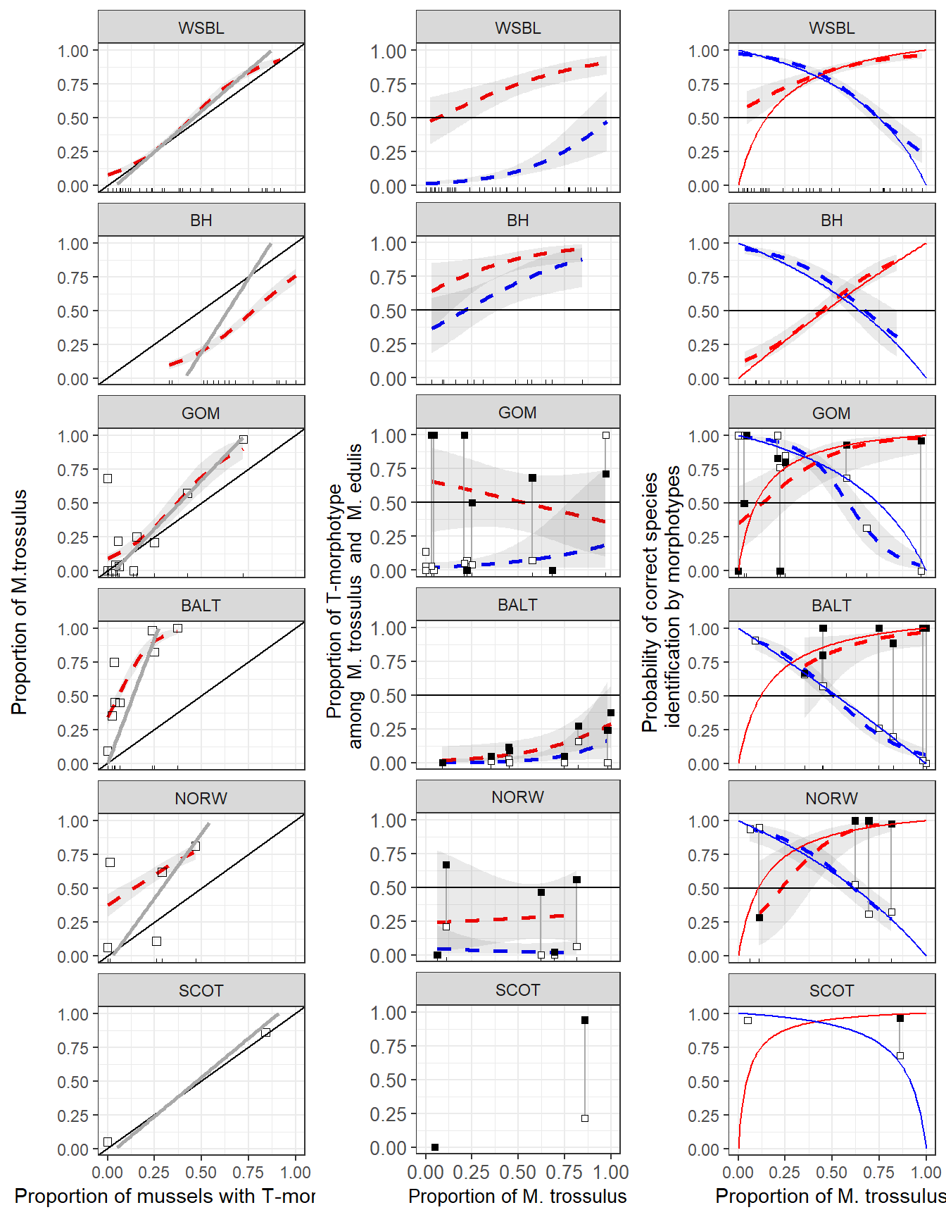

Figure 3. Predictive power of the morphotype test in different regions. (A) Dependence of Ptros on proportion of T-morphotype mussels. Dotted line is empirical regression line (Model 4). Solid gray line - prediction accordingly to Eq. 3. Solid black lines represent Y=X dependence. (B) Probability to find a mussel with T-morphotype among *M.edulis* and *M.trossulus*. Dotted lines correspond to regression Model 5. Black squares - M.trossulus, white - M.edulis. (C) Probability of correct species identification by morphotype-test. Dotted lines are empirical regression lines (Model 6). Sold red line - prediction by Eq.1, Solid blue line - prediction by Eq.2. Shedded areas around regression lines represent 95% CI. In all cases dots represent observed proportons in samples.

While *P(T|edu)* estimates were low everywhere but in *BH*, *P(T|tros)* demonstrated a strong variation among sets and a noticeable variation within some sets (**Fig. 3**; Model 5; **Table 1**). Similarly to WSBL, most *M. trossulus* had T-morphotypes in GOM and SCOT but not in BALT and NORW. For *Ptros*=0.5, expected differences in the morphotype frequencies between the species were about 44% for GOM, 6% for BALTand 24% for NORW. A significant positive dependence of the frequencies of T-morphotype on *Ptros* among conspecific genotypes, which was so prominent in the White and the Barents Sea, was recorded elsewhere only in BALTfor *P(T|tros)* (Table 1).

The pattern of dependence of *P(tros|T)* and *P(edu|E)* on *Ptros* in GOM, BALT and NORW (Model 6. Fig. ++, Table +) was the same as in the samples from the Kola Peninsula (Model 3. **Fig. 2**, **Table 1**): *P(tros|T)* increased with the increasing *Ptros*, while *P(edu|E)* showed an opposite tendency. To simplify and formalize the comparison, we provide the predictions of Model 6 for equally mixed populations (*Ptros*=0.5) together with their 95% confidence intervals in Table 2, where actual proportions of *M. trossulus* among T-morphotypes (*P(T|tros)*) and *M. edulis* among E-morphotypes (*P(T|edu)*) in pooled samples from the respected sets are also provided.

**Table 2.** Proportions of *M. trossulus* among T-morphotypes (*P(tros|T)*) and proportions of *M. edulis* among E-morphotypes (*P(edu|E)*) in pooled samples (direct count) and in equally mixed samples (predictions by the regression Model 6) in different sample sets. Low and upper boundaries of 95% confidence intervals are provided for predicted values (in brackets).

|  |  |  |  |  |
| --- | --- | --- | --- | --- |
|  | P(edu|E) | | P(tros|T) | |
| Set | Ptros=0.5 | In the data | Ptros=0.5 | In the data |
| WBL | 0.77 (0.73-0.81) | 0.86 | 0.85 (0.82-0.89) | 0.86 |
| BH | 0.70 (0.61-0.78) | 0.84 | 0.57 (0.51-0.63) | 0.48 |
| GOM | 0.66 (0.54-0.77) | 0.86 | 0.86 (0.68-0.95) | 0.80 |
| BALT | 0.51 (0.44-0.58) | 0.46 | 0.82 (0.58-0.94) | 0.93 |
| NORW | 0.64 (0.53-0.74) | 0.51 | 0.86 (0.68-0.95) | 0.93 |
| SCOT | - | 0.90 | - | 0.96 |

For equally mixed populations the predictive values of *P(edu|E)* in BALT did not differ statistically significantly from 0.5, which corresponds to an equal probability of correct and incorrect identification. At the same time, the probabilities of correct identification of *M. trossulus* by the T-morphotype in GOM, Balt and Norw were quite high (for the range of *Ptros*>0.5). In general, highest predictive values for both species were revealed in WSBL.

Using the coefficients of the regression models Model 4 and Model 6 (**Table 1**), we constructed a set of formulas predicting the taxonomic structure (*Ptros*) and the probability of correct species identification (*P(tros|T)*, *P(edu|E)*) using the morphotype test (Table 3). These formulas were further used for the comparison of predictions made with these regression models and the predictions proposed by Eq. 1, 2 and 3.

**Table 3.** Formulas used for taxonomic and individual assignment using morphotype tests in different sample sets accordingly to the regression model’s coefficients represented in Table 1.

Надо вставить таблицу из Figures_final_version.html

Variation in morphotype frequencies between *M. edulis* and *M. trossulus* within and between contact zones revealed in the study is illustrated in **Fig. 1**, where the estimates of *P(T|edu)* and *P(T|tros)* in pooled samples from different sets are provided. *P(T|edu)* was 0.53 in the saline Barents Sea (BH) and less than 10% in all the other sets. In its turn, *P(T|tros)* was 0.17 in BALT, 0.42 in NORW, 0.49 in the GOM and more than 0.75 in WSBL and SCOT. *P(T|tros)* estimates in Norway and the Gulf of Maine were much affected by the outlier samples (see above). If we discard these samples, *P(T|tros)* will make up 0.54 in Norway and 0.71 in the Gulf of Maine.

**Fig. 1** also shows the morphotype frequencies in putatively pure populations of species out of the contact zones studied. Within the ancestral range of *M. trossulus* in the Pacific, the populations were nearly monomorphic for the T-morphotype. In the Passamaquoddy Bay *P(T|tros)* was 0.81, i.e. close to that in most of *M. trossulus* populations in the Gulf of Maine. All reference *M. edulis* populations from temperate areas (Long Island Sound and Cape Cod in Western Atlantic, Northern and Norwegian Seas in Europe) were nearly monomorphic for the E-morphotype. At the northeast extreme of the species range in East Atlantic, in the Southwestern Barents Sea, *P(T|edu)* varied considerably between samples, in particular between samples from brackish (range 0-3%) and saline (0.35-0.70%) localities (see ESM Table 2), as it did along the Barents sea coast of the Kola Peninsula. Increased *P(T|edu)* was also recorded in two northernmost samples from Western Atlantic, Greenland (0.66) and the Gulf of St. Lawrence (0.73).

**Associations between morphotypes and shell size**

There was no clear statistical relationship between the size and the morphotype of conspecific mussels. At the level of individual samples, the probability of finding a T-morphotype increased with the mussel size (a positive slope-term of the regression) in 16 out of 34 informative comparisons (when species-specific genotypes were both present and polymorphic for morphotypes) for *M. edulis* and in 17 out of 43 comparisons for *M. trossulus*. The slope-terms of the regression models were individually significant (p<0.05) in four cases for *M. edulus* and in four cases for *M. trossulus*, but only in one case when the correction for multiple testing was applied (sample Bergen_MV, see **S3 table**). We also checked the presence of any patterns in residuals from Model 6 as a function of mussel size but no one was found.

**Prediction of taxonomic structure of populations and predictive values of the morphotype test based on probability calculators.**

We applied Eq.1 and Eq. 2 (predictive values as a function of *Ptros*, *P(T|tros)* and *P(T|edu)*, “genotype by morphotype calculator”) and Eq. 3 (“*Ptros* by *PT* calculator”) using as an input the data on all possible pairs of samples from *WSBL* and compared the values predicted by these equations with those predicted by regression models 6 and 4, respectively (**Table 3**).

Fig. 4 illustrates the goodness of correspondence of the two predictions depending on the genetic constitution of the paired samples as expressed by the Delta index.

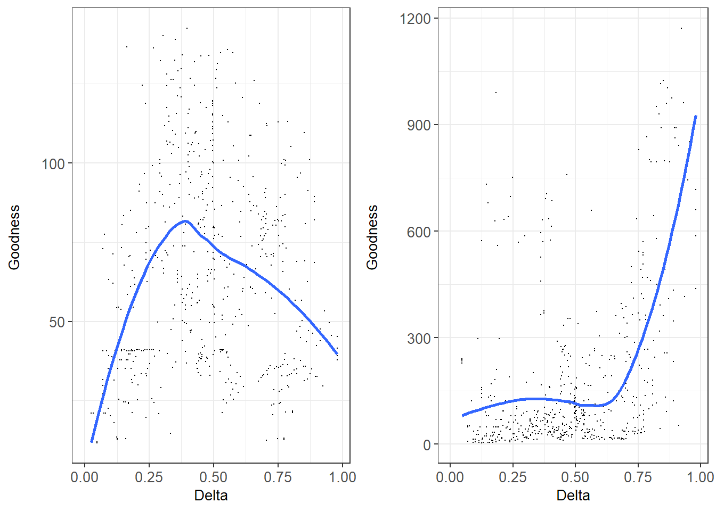

Поменять местами лево и право! Fig. +. Correspondence between “*Ptros* by *PT* calculator” (Eq. 3, left graph) and “genotype by morphotype calculator” predictions (Eq. 1-2, right graph) and regression Model 6 and Model 4, respectively. Each point corresponds to a unique pair combination of samples from WSBL set. OX axis reflects dissimilarity of genetic structure in each pair (Delta) (for pure conspecific samples Delta takes a value of zero, for equally mixed samples – 0.5, for two pure heterospecific samples - 1). OY: goodness of correspondence between assessment of predictive values by equations and regression models.

The best predictions of *Ptros* were obtained when the most dissimilar samples consisting of nearly pure *M. edulis* and *M. trossulus* were used (Delta >0.75), while the best predictions of *P(edu|E)* and *P(tros|T)* values were obtained when the most mixed samples (*Ptros* of both samples close to 0.5; range of Delta 0.25-0.5) were taken for calibration.

Therefore, to predict *Ptros* using “*Ptros* by *PT* calculator” one should use most dissimilar samples to assess *P(T|edu)* and *P(T|tros)* as parameters. To predict *P(edu|E)* and *P(tros|T)* using “genotype by morphotype calculator” one should assess the parameters using the most mixed samples. However the *Ptros* as input in Eq.1-2 should be calculated as in the previous case i.e. using the most dissimilar samples and Eq. 3. To illustrate the approach (see Fig. 3) for WSBL, BH, GOM and BALT we used pooled sets of samples with *Ptros* <0.1 and >0.8 and 0.45 < *Ptros* < 0.65 to calibrate calculators as described above (samples included are indicated in S1 table). We used pooled but not individual samples to avoid basements due to small sample size. We used given ranges of *Ptros* because of lack of *M. trossulus*-dominated samples in most sets. For NORW and SCOT we pooled all samples because of lack of data.

Visual inspection of Fig. 3a revealed nearly ideal correspondence between regression lines and predictions of “*Ptros* by *PT* calculator” in the case of WSBS and GOM. In the case of SCOT where only two samples were available the line derived from Eq3 approached the Y=X line. Not ideal but rather close correspondence was observed in the case of BALT, deviation was due to extremely high slope term of the regression. *Ptros* was slightly underestimated by the calculator in this case. The worst correspondence between Eq3 and Model 4 was observed in the case of NORW and BH. In BH *Ptros* was severely overestimated by the calculator (situation opposite to that in BALT). In NORW both regression and predictions of calculator were severely affected by the outlier sample.

As for “genotype by morphotype calculator”, predictions generally were in good correspondence with regression lines (calculator’s lines were within 95% CI of regressions). Deviations were observed for *P(edu|E)* predictions in WSBL for *Ptros*<0.25 and *P(edu|E)* in GOM for *Ptros*>0.6 i.e. in the *Ptros* ranges corresponding to minor species prevalence.

An exercise with “lazy *Ptros* by *PT* calculator” (the highest and lowest *PT* in samples from regional sets are used as *P(T|tros)* and *P(T|edu)* parameters of Eq. 3) brought the next results (S2 Fig). In WS, BL and GOM correspondence between observed and predicted *Ptros* values in samples was generally good. In BH, *Ptros* was slightly underestimated by calculator due to absence of pure *M. trossulus* samples in the data and formal choice of a numerically small (N=22; see S1 table) sample with the highest *PT* but not the highest *Ptros* as “calibrating” one. For BALT and NORW discrepancies were much stronger for the same reasons as in case of “*Ptros* by *PT* calculator” (see above).

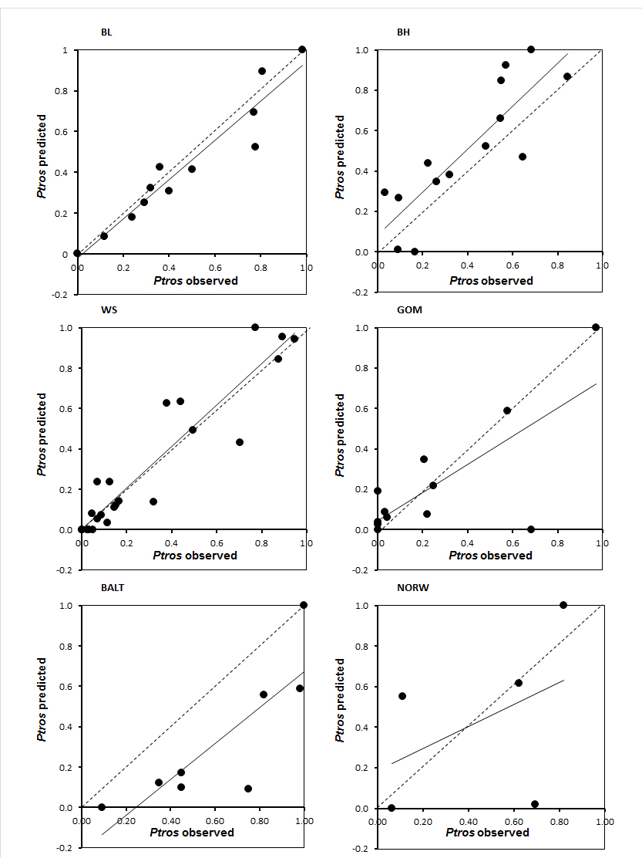

**S3 Fig.** Correspondence between empirical estimates of *Ptros* in samples and predictions of “lazy *Ptros* by *PT* calculator” (the highest and lowest *PT* in samples from regional sets are used as *P(T|tros)* and *P(T|edu)* parameters of Eq. 3). Dots – estimates, solid line – linear regression, dashed line – Y=X line.

**Discussion**

The knowledge about the taxonomic structure of populations and the rough classification of individuals into “species” is often more valuable to the blue mussel researchers than the precise information about genetic affinity (e.g. Structure q-value) of any given mussel. In the light of this, our finding that *M. edulis* and *M. trossulus* genotypes in the White Sea differed by the frequencies of the shell morphotypes (Katolikova et al. 2016) seemed very promising. It gave hope that this knowledge could be obtained for these species by a quick examination of the inner side of the shells, without genotyping, which is expensive, time-consuming and requires soft tissues (genotyping of shell material is possible [Geist et al. 2008; Der Sarkissian 2020] but is not yet routine practice). In this study we reanalyzed abundant data from Katolikova et al. 2016 and derived robust relationships between the proportions of the morphotypes in the populations and their taxonomic structure as well as between the proportions of the morphotypes in samples and the probabilities of mussels of different morphotypes being *M. trossulus* and *M. edulis*. These relationships could be used for a reliable prediction of the taxonomic structure of any population in the White Sea. Moreover, any mussel in an equally mixed population could be identified as *M. trossulus* or *M. edulis* with the accuracy of about 80% (a bit less than it was predicted basing on frequencies of morphotypes in pooled data on the White Sea *M. edulis* and *M. trossulus*, see Introduction). With the increasing imbalance between the species (and hence the morphotypes) in a population, the identification of the dominant species became more reliable though the identification of the minor species became less so.

The ultimate goal of our study was to find out whether the possibility of identifying *M. edulis* and *M. trossulus* by the morphotype was a “privilege” of the researchers working at the White Sea or whether this approach could be used for identification of these two species worldwide. Though our data on the contact zones between the species outside Northern Russia were limited, our results indicate that this approach may be useful everywhere since interspecific differences in the morphotype frequencies were ubiquitous and unidirectional. However, its utility is evidently different for different contact zones due to a considerable variation in the morphotype frequencies in conspecific populations from different zones and sometimes also from the same zone.

Though the hypotheses that different mussel species may differ by the extent of the nacreous layer development under the ligament nympha has been suggested a long time ago (Zolotarev, Shurova 1997; Vervoenen et al. 2000), the morphotypes were actually put to use for the identification of species only in the study by Khaitov et al. (2018) (see below). Here we show that the morphotype test is a promising tool. Once it has been evaluated, i.e. associations between morphotypes and species-specific genotypes have been analyzed at the individual and the population level, it will hopefully deserve more attention from the blue mussel researchers.

To note, another morphological express method for the diagnostics of *M. trossulus* and *M. edulis* was suggested by Beaumont et al. (2008) who showed that commercially damaging “fragile mussels” recorded on *M. edulis* plantations in Loch Etive (Scotland) were genetically similar to *M. trossulus*. The “fragile” mussels appeared to differ from *M. edulis* (and the reference *M. galloprovincialis*) by a complex of shell traits including form, expressiveness of growth ridges as well as the colour of the inside. However, this promising approach to the identification of species based on these traits has remained underdeveloped. By comparing the photos of mussel shells in Beaumont et al. (2008) with the photos of shells from our Barents Sea samples (ESM Fig. 1), one can see that the differences between these two species in Scotland are more striking that in the Barents Sea.

We will start with the discussion of the patterns of variation of the morphotype frequencies revealed in our study. Then we will discuss the applicability of the morphotype test in different contact zones. In the closing section, the limitations of single-marker taxonomic tests for blue mussels and other taxa will be outlined.

**Factors affecting morphotype frequencies in conspecifics.**

Some variation in the morphotype frequencies was observed among putatively pure conspecific populations sampled at a distance from the contact zones. The samples of *M. edulis* from the temperate seas (i.e. all except those from the SE Barents Sea and Greenland) appeared to be nearly monomorphic for the E-morphotype while the northern samples were more polymorphic and diverse. In turn, the reference populations of *M. trossulus* from Western Pacific and from Washington in Eastern Pacific were nearly monomorphic for the T-morphotype. Nevertheless we cannot be sure that *M. trossulus* lacks geographic variation in its ancestral range in the Pacific and that the T-morphotype is an “ancestral” state for this species. Zolotarev (2002) identified the morphotypes in small samples representing genotyped collections from McDonald et al. (1991). His results, while generally similar to ours, indicated elevated frequencies of the E-morphotype in *M. trossulus* from Oregon (East Pacific). However, Zolotarev’s data should be treated with caution, because he used a more fractional classification of the morphotypes and identified them macroscopically, and also because Oregon is close to a contact zone between *M. trossulus* and *M. galloprovincialis* (McDonald et al. 1991), and the latter species is characterized by the E-morphotype (Zolotarev, Shurova 1997; Zolotarev, 2002).

In *M. trossulus* the variation in the morphotype frequencies between the contact zones was mostly associated with the elevated frequencies of the E-morphotypes in Norway and, especially, in the Baltic Sea. The variation within contact zones was mostly due to the few “outlier” samples from the Gulf of Maine and Norway. On the contrary, *M. edulis* demonstrated small variation between zones, the frequency of the T-morphotype being universally low. There was, however, one notable exception. An elevated (up to 40%) frequency of the T-morphotypes was observed in samples from saline localities (salinity above 30 ppt) in Northern Russia. A similar salinity-related variation was also present in *M. edulis* from the more eastern areas of the Barents Sea, at some distance from the contact zone between these species along the Kola Peninsula coast.

Finally, an analysis of the abundant material from the White and the Barents Sea revealed variation in the morphotype frequencies related with the taxonomic structure of the populations. The frequencies of the T-morphotype increased both among *M. edulis* and among *M. trossulus* genotypes with the increasing prevalence of *M. trossulus* in the samples.

Originality of *M. trossulus* from Norway and the Baltic Sea.

*M. trossulus* from the Baltic Sea and Norway were characterized by extremely high frequencies of the E-morphotype. Two hypotheses, which are not mutually exclusive, can be offered to explain this phenomenon. One hypothesis likens the morphotypes or, more specifically, the underlying hypothetical genes, to alleles of taxonomically diagnostic loci that can introgress between species as a result of extensive hybridization and backcrossing. Genetic studies show that the Baltic *M. trossulus* hybridizes more freely with *M. edulis* and is stronger introgressed by *M. edulis* genes than any other Atlantic population (Vainola, Strelkov 2011; Fraisse et al. 2016). Due to its mixed genetic nature, the Baltic mussel is sometimes considered as a unique *M. edulis* x *M. trossulus* hybrid swarm, which is fundamentally different from the “oceanic” *M. trossulus* (Vainola, Strelkov 2011). While the genetic data from Norway are limited, hybridization is apparently more extensive there than in most other contact zones though not as extensive as in the Baltic (Vainola, Strelkov 2011; Wenne et al. 2020). Besides, it is evident that the local Norwegian *M. trossulus* populations can be strongly introgressed by *M. edulis* genes (Śmietanka, Burzyński 2017).

According to the second hypothesis, the frequency of the T-morphotype in *M. trossulus* is reduced under the influence of some environmental factors, both micro- and macrogeographical. We suspect that the nearly zeros frequencies of the T-morphotype in the “outlier” samples (one from Norway, almost from the same place as the other Bergen samples, and two from Cobscook Bay in the Gulf of Maine (CBCP, CBSC in S1 Table)) could be explained by the impact of some cryptic local factors, though a more prosaic explanation such as the mislabeling of mussels in the collections cannot be entirely ruled out.

Salinity-related variation in *M. edulis*.

While local factors putatively affecting morphotype frequencies in *M. trossulus* remained cryptic, in the Barents Sea we managed to identify one such factor governing morphotype frequencies in *M. edilus*: salinity or a factor/factors linked to salinity. The eastern part of the Barents Sea, where this variation was evident, is also the coldest. The border between the more temperate populations of *M.edulis* with “normal” (high) frequencies of the E-morphotype and the more Arctic populations with lower frequencies of the E-morphotype in oceanic habitats runs somewhere between North Cape and Kola Bay (**Fig. 1**). This area has mean annual, summer and winter sea surface temperatures of about 6°C, 9°C and 4°C, respectively (*http://esimo.oceanography.ru/).*

The functional significance of the morphological character underlying the E- and the T- morphotype—the presence/absence of the nacreous layer under the ligament—is unclear. However, we suspect that the morphotypes might differ in conspecifics by the degree of development of the nacreous layer itself and thus in the thickness and strength of the shell. The nacreous shell layer is mechanically the strongest (Currey and Taylor, 1974). *M. trossulus*, which is usually marked by the T-morphotype, generally has a thinner nacreous layer and a more fragile shell than *M. edulis* (cf. Beaumont et al. 2008, see above). *M. edulis* of the T-morphotype might have an underdeveloped nacreous layer and a thinner shell than the conspecifics of the E-morphotype.

Can we expect the shell thickness and structure to differ in mussels from saline (oceanic) and brackish (estuarine) environments in the Arctic? Apart from the low temperatures, the Arctic Sea is characterized by a reduced concentration of calcium carbonates (Steinacher et al. 2009) and, seasonally, by low concentrations of planktonic algae, which the mussels feed on (Zenkevitch 1963). Estuarine habitats are generally characterized by the lowest saturation of carbonates but the highest concentrations of food (seston), which is due to the riverine discharge (Duarte et al. 2020). This is exemplified by the highest biomasses of *Mytilus* in estuaries in the Barents Sea (Bufalova et al. 2005) and elsewhere (Seed, Suchanek 1992). Mussels need both calcium carbonates and energy for shell growth and maintenance. In estuaries, the nacreous layer of the mussel shell is prone to dissolution and corrosion (Melzner et al. 2011) but the mussels can still keep their shells strong if the food is sufficient (Melzner et al. 2011; Duarte et al. 2020). If the food is limited, the energy is likely to be allocated to the maintenance of the somatic mass rather than the conservation of the shell (Melzner et al. 2011 and references therein).

Our hypothesis explaining the assumed differences in the degree of the nacreous layer development between *M. edulis* from the brackish and the saline localities in the Arctic is that in the estuaries the mussels allocate more energy for shell maintenance thus keeping their nacreous layer thick while in less corrosive but more famished oceanic habitats they allocate more energy for somatic growth keeping their nacreous layer thin. As a result, the majority of *M. edulis* from the saline localities has the undeveloped nacreous layer. It is noteworthy that in the areas where *M. edulis* demonstrated salinity-related variation, the morphotype frequencies in *M. trossulus* varied negligibly. This could be attributed to a generally lower shell plasticity in “oceanic” (non-Baltic) *M. trossulus* than in *M. edulis* in response to the environmental stressors (Lowen et al., 2013, see Khaitov et al. 2018 for more discussion).

To remember, apart from the eastern Barents Sea reduced frequencies of the E-morphotype were also revealed in northernmost populations of *M. edulis* from Greenland and the Gulf of St. Lawrence in Western Atlantic (**Fig. 1**). This exemplifies that this is an Arctic phenomenon. Unfortunately salinity in sampling localities is unknown.

Variation with the taxonomic structure.

A positive correlation of the T-morphotype frequencies both in *M. edulis* and *M. trossulus* with the prevalence of *M. trossulus* in the representative data sets from the White and the Barents Sea was to be expected, bearing in mind that *M. edulis* and *M. trossulus* genotypes are defined by the dominance of the conspecific genes in multilocus genotypes. Hence both genotypes included purebreds as well as hybrids. From a detailed analysis of the White Sea data (Katolikova et al. 2016) we know that the frequencies of hybrids are approximately the same in all the samples (18% on the average), hybrids are intermediate in morphotype frequencies between purebred *M. edulis* and *M. trossulus* but usually closer to species dominating the population (Katolikova et al. 2016). This means that in our analyses “*M. edulis* genotypes” from *M. trossulus*-dominated populations included mostly hybrids with an increased frequency of the T-morphotype as compared to the “*M. edulis* genotypes” in *M.edulis*-dominated populations. In turn, “*M. trossulus* genotypes” from *M. edulis*-dominated populations included mostly hybrids with a decreased frequency of the T-morphotype as compared to such genotypes in *M.trossulus*-dominated populations. This is the cause of the observed unidirectional variation in the morphotype frequencies among *M. edulis* and *M. trossulus* genotypes with the changing taxonomic structure of populations. To note, the variation of sensitivity and specificity of clinical diagnostic tests with the changing disease prevalence is often observed (Leeflang et al. 2009, 2013). For instance, a test is likely to perform better a patient population with a higher disease prevalence, which may include more severely diseased patients (Leeflang et al. 2009).

**Applications of morphotype test**

In our opinion, the morphotype test can be universally applied as an alternative to genotyping in three fields. Firstly, it can be used for monitoring the taxonomic structure of commercial and wild populations, in particular used in the “mussel watch” contaminant monitoring programs, because deviations of the morphotype frequencies may be a warning sign of the taxonomic change. Secondly, it may prove useful for mapping the species distribution. Detailed mapping is likely to require a great number of samples because the distribution of the species in contact zones is usually highly mosaic (see Katolikova et al. 2016 and references therein). Thirdly, the morphotype test can be used when only dead mussel shells are available, e.g. for interpretations of the taxonomic structure of natural history collections or samples of dead shells left behind by some mussel predators.

Identification of taxonomic structure of populations from contact zones.

A reliable application of the morphotype test requires good genotyped references. Ideally, empirical relationships should be established between the morphotype frequencies and the taxonomic structure of populations in a given contact zone, as they were in our study (**Table 3**). Even our regressions require further refinement for all the contact zones except Northern Russia, since they are based on a relatively small number of samples. On a reassuring note, for mixed populations from the Baltic and the Gulf of Maine as well as for the populations from Northwestern Greenland and the American coast north of the Gulf of Maine unexamined in this study, collections of genotyped mussels probably remain from previous extensive population genetic studies (e.g. MacDonald et al. 1991; Bates, Innes 1995; Rawson et al. 2001; Stuckas et al. 2017; Wenne et al. 2020). The collections could be used for further calibration of the morphotype test for these contact zones. If such an effort is undertaken for Greenland and subarctic American populations, salinity and trophic conditions should be considered as a potential covariates of the morphotype variation.

The relationships between the morphotype frequencies and the taxonomic structure of populations will have to be established *de novo* in understudied or, potentially, new contact zones. Should the genotyping of more than a few samples covering the range of the morphotype frequencies prove impractical, the relationships could be approximated using the data on at least two genotyped samples with the most contrasting structure (ideally, pure *M. edulis* and pure *M. trossulus*) and the “*Ptros* by *PT* calculator” (eq. 3) (cf. Fig. 2). At the very least the relationships could be weighed roughly without any genotyping, by taking minimal and maximal morphotype frequencies in regional populations as a hypothesis of such in pure *M. edulis* and pure *M. trossulus* (“the lazy *Ptros* by *PT* calculator”, cf. S3 Fig). Certainly such predictions should be treated with great caution.

We claim that the morphotype test may be useful for the detection of new contact zones and for their formal genetic description. The procedure would involve a preliminary selection, with the help of the morphotype frequencies, of the purest samples needed for the verification of the species identity and of most mixed ones needed for the assessment of the extent of hybridization and mixing.

In case of historical or archaeological collections, the only way to translate the proportion of the T-morphotypes in the samples into the taxonomic structure is to resort to the actualistic principle. If the correspondence between the morphotypes and the genotypes was assessed in the area of the sample origin, one can use this information for retrognosis. This should be possible for quantitatively representative samples though not for small samples or single shells. Unfortunately, the morphotype test is unlikely to be useful for the interpretation of paleontological data since the morphotype frequencies in conspecifics are affected both by geography and by the local oceanographic conditions, which are variable at a large time scale.

Individual identification.

The possibility to identify individual mussels by the morphotype seems to be the “privilege” of researchers working at the White Sea and brackish environments of the Barents Sea. The morphotype test also seems to be promising for individual assignment in the Gulf of Maine, except in the outlier samples (see above) and, possibly, in Scotland (unfortunately, the Scottish populations were represented in our analysis only by two samples). In the Baltic Sea and Norway the morphotype test worked reliably only for *M. trossulus* mussels, while in the saline areas in the Barents Sea it did so only for *M. edulis* mussels.

An example of the application of the morphotype test for individual assignment can be found in our previous study (Khaitov et al. 2018). Aiming to find out whether the starfish *Asterias rubens* distinguished between *M. edulis* and *M. trossulus* in the White Sea, we sampled mussels in populations with high and low frequencies of the T-morphotype, mixed them in equal proportions in experimental cages, and, after acclimation to ambient conditions, offered to the starfishes. These predators selectively consumed mussels of the T-morphotype, which was interpreted as a preference towards *M. trossulus* (Khaitov et al. 2018). Now we know that an alternative and probably more formal experimental design could be to use sympatric mussels of T- and E-morphotypes from the most mixed population. Under both designs, the accuracy of individual assignment of experimental mussels would be nearly the same.

We would like to stress that, if one plans to use the morphotype test for individual assignment, reliable genetic references are absolutely indispensable. These could be either empirical relationships between the proportions of the morphotypes in the samples and the probabilities of mussels of different morphotypes being *M. trossulus* or *M.* edulis or control genotyping of mussels from the populations of interest. Still, it is noteworthy that the accuracy of individual identification of mussels could be approximated basing on the morphotype frequencies in three “calibration” samples (those with the maximum, the minimum and the intermediate proportions of species) and eq. 1-3 (cf. Fig. 2).

***Pitfalls of the morphotype test***

The morphotype test is not without pitfalls. Evident risks are the next. An underestimation of *M. trossulus* by morphotypes in some populations (such as those in Norway and the Gulf of Maine, which were the sources of the “outlier” samples). The bias generated by a non-random association of morphotypes with size (or age) of conspecific mussels such as was observed in very rare (about 2%) samples. Uncertainties in the application of the test to populations from intermediate salinities (about 30 ppt) in the Barents Sea. To note, four out of the five samples with a significant non-random association between the morphotypes and the size were from Tyuva inlet (**S3 table**) right at the border between brackish and full saline areas of the Kola Bay. It is possible that temporal or ontogenetic trends in the morphotype frequencies are a local Barents Sea phenomenon related to the unusual salinity conditions as in Tyuva.

**Uses and abuses of single marker taxonomic tests**

Traditional species identification relies on diagnostic (fixed) traits of the organism, usually included in the morphological diagnosis. In the terms of the probability theory, it means that the probability of an individual with a species-specific diagnostic marker being a representative of the species in question is equal to one: *P(species|trait)* = 1. However, this probability may decrease for two reasons. An obvious reason is associated with deficient skills of the researcher or defective condition of the specimen. A less obvious source is an ambiguity in the diagnosticity of a trait. It is generally impossible to determine whether diagnostic characters are indeed fixed if the sample size is finite (Wiens, Servedio 2000). Hence, in practice, for diagnostic markers *P(species|trait)* ≤ 1.

In case of semi-diagnostic traits, the researchers do not identify the species of a given individual but assess the probability of its assignment to one or another species. For these traits, *P(species|trait)* < 1. Similarly, dealing with population assessment we assess the probabilities of finding the representatives of one or another species in a sample but not the true proportion. The most critical point is that *P(species|trait)* is not constant but varies, yet in predictable manner, with the prevalence of a species in a range [0;1].

A correct application of tests based on semi-diagnostic markers, such as clinical diagnostic tests, ultimately requires a “reference standard” – the reference used for verification of the index test results (Banoo et al. 2006). In our case study of the blue mussels, we used as references the groups of multilocus genotypes (from 4 to 171 645 loci depending on the geographical sample set) defined by the dominance of alleles characteristic of one or the other species. These groups did not represent true species. They included hybrids, some of which (e.g. first- and second generation hybrids) were assigned into groups randomly. To note, multilocus genotyping is seldom employed for identification of cryptic mussel species. Most studies rely on singular or few “standard” diagnostic PCR-based markers, usually nuclear Me15/16 and ITS and mitochondrial COI or 16S markers (Larrian et al. 2019). Offering the morphotype test as a rough but cost-efficient alternative to genotyping, we have to assess its reliability as compared to single- and few locus tests. It has been long known that the efficiency of “diagnostic” markers for discrimination between *M. edulis* and *M. trossulus* is different in contact zones in Western Atlantic (i.e. the Gulf of Maine) and the Baltic Sea. In Western Atlantic the species are nearly fixed for alternative alleles at Me15/16, ITS and mitochondrial markers, while in the Baltic Sea intraspecific differences at these loci are 20%, 32% and 0%, respectively, due to a mass introgression of *M. edulis* genes into the local *M. trossulus* genome (Riginos, Cunningham 2005). For comparison, the differences in morphotype frequencies between species in the Gulf of Maine and the Baltic Sea are 44% and 6%. As far as we know, the efficiency of taxonomic tests based on singular or few “standard” loci has not been carefully evaluated for other *M. edulis* – *M. trossulus* contact zones, though some attempts have been made (see Vainola, Strelkov 2011 and Wilson et al. 2018). The recent population genomic studies of hybridizing *Mytilus* species indicate that these species can altogether lack fixed genetic differences due to ubiquitous introgression and that loci can introgress in unpredictable manner in different contact zones (Fraïsse et al. 2016; Simon et al. 2019). On these grounds, the conventional approach of mussel species identification by singular molecular markers has been criticized (Simon et al. 2019). We do not claim that the morphotype test would fare better than most single-locus taxonomic tests in any contact zone between *M. edulis* and *M. trossulus*. At the same time, we would like to point out that the performance of these tests has not been evaluated in most contact zones, while that of the morphotype test has been.

A situation when one has to rely on a singular “informal” semi-diagnostic character to distinguish morphologically such old evolutionary lineages as *M. edulis* and *M. trossulus* is certainly uncommon in taxonomy. At the same time, it is not unique. There are other taxa, which lack fixed diagnostic morphological characters and are identified by semi-diagnostic traits, individual or complex such as like the coordinates of multifactorial analysis. These taxa are subspecies defined according to the 75% rule (Amadon, 1949), cryptic species with statistical differentiation (sensu Chenuil et al. 2019) and hybridizing species that secondarily lost fixed differences due to introgressive hybridization (Fitzpatrick et al. 2015). Therefore, we hope that our experience of dealing with a non-fixed taxonomic character would be interesting not only to our colleagues working with blue mussels but also to the researchers who study sympatric taxa with vague morphologies and semi-isolated gene pools.